1. Follow the instructions from “Lab 08: Password Cracking with John the Ripper and Hashcat.”
   * **Note: For all of the screenshots in the next steps, make sure to include the entire browser window to show that you are logged in to Netlab.**
2. Start with Section 1, “Generating Password Lists for Password Cracking,” and capture screenshots of the following:
   * Step 8 output

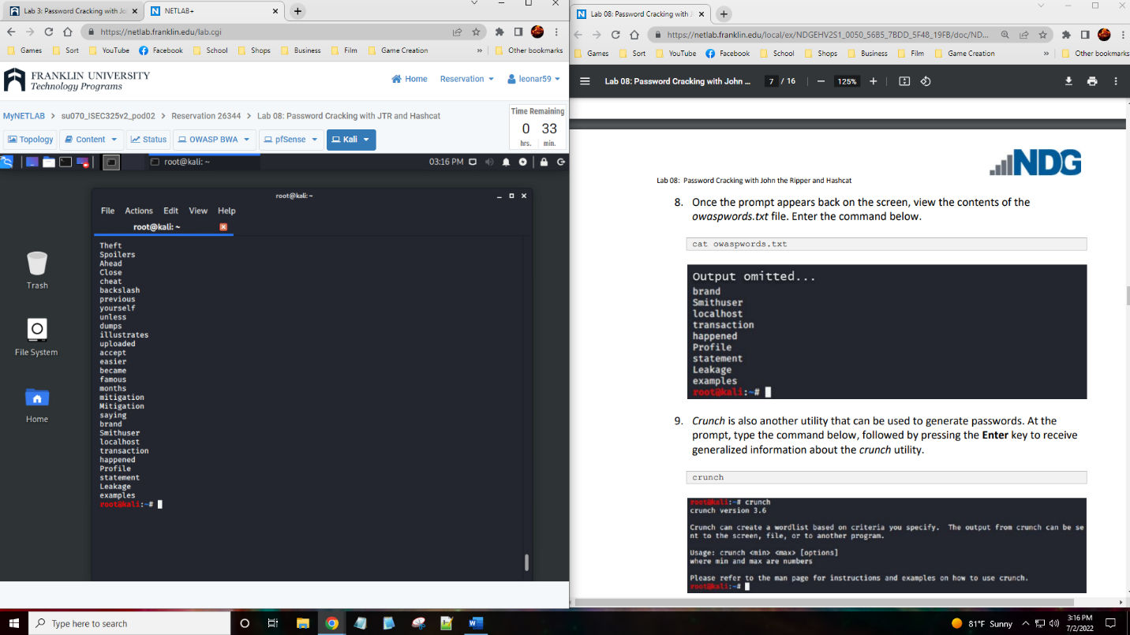

* + “tail mylist.txt” after Step 12 is complete

1. Continue with Section 2, “Create User Accounts to be Cracked,” and capture a screenshot of the following:
   * Step 7 output

1. Continue with Section 3, “Password Cracking Using John the Ripper,” and capture a screenshot of the following:
   * Step 3 output

1. Continue with Section 4, “Password Cracking Using Hashcat,” and capture a screenshot of the following:
   * Step 12 output

1. Summary and Reflection: In a few paragraphs, reflect on what you learned through this lab assignment. Was there anything surprising or unexpected? Was there anything worth investigating further?

I found that testing password cracking is not as hard as it sounds. The lab walks us through two different means of password cracking that are easy to do with the steps provided. The idea of password cracking makes me think of how on tv shows the person will be doing a very convoluted thing to get the password they need. The lab took me less than an hour which makes me think of how dramatized the password cracking is in tv shows. I find these labs to be quite fun as it gives us scenarios that we could come across in our life. I love the security aspects which means that each lab that shows how to get through security or what happens without it is more fun.